**gd'gf k|Zg kq**

**sIfM @ प्रथम त्रैमासिक परीक्षा—@)*@**

**D-**

**ljifoM ;]/f]km]/f]**

**!= Hff]8f ldnfpg'xf];\ M -$_**

sfsf k9fpg'x'G5

cfdf a'afsf] efO

d 3/sf] sfd u5'{

**@= vfnL 7fpF eg'{xf]; M -$_**

s= d]/f] a'afsL cfdfnfO d __________eG5' .

v= xfdL xfd|f __________ofsdf /fVg'k5{ .

u= of]un] xfd|f z/L/nfO{ __________agfpF5 .

3= xfdL __________a:g'k5{ .

***-xh'/cfdf, l;wf,, h'Qf, km'lt{nf]_***

**#= l7s a]l7s n]Vg'xf];M -$_**

s= xfdLn] cfkm' eGbf 7'nfnfO{ ;Ddfg ug'{ k5{ .

v= xfdLn] ;dfg l7s 7fpFdf /fVg' x'b}g .

u= xfdLn] kf]ifs vfg]s'/f vfg'k5{ .

3= cfuf] v]nfpg' /fd|f] afgL xf] .

**$= tnsf lrqx¿sf] gfd n]Vg'xf];\ . -$_**

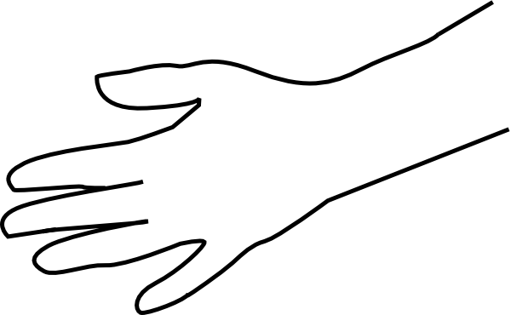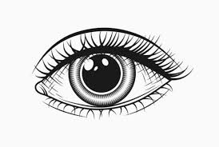

**%= tnsf] gfd n]Vg'xf];\ . -*_**

c= v]nf}gfx¿sf] gfd

__________ __________

cf= z/L/sf] efusf[] gfd

__________ __________

O= k|sfzsf ;|f]tx¿

__________ __________

O{= lzi6rf/ a'emfpg] zAbx¿

__________ __________

**^= tnsf k|Zgx¿sf] pQ/ n]Vg'xf];\ . -!)_**

s= tkfO{+sf slt cf]6f sfg 5g\L

v= ofu ubf{ xfdLnfO{ s:tf] cg'ej x'G5<

u= tkfO{+sf slt cf]6f sfg 5g<

3= Wjlg eg]sf] s] xf]<

ª= xfdLnfO{ a:t' b]Vg s] rflxG5?

**&= kf]ifs / kq' vfg]s'/fsf] ;"rL tof/ ug'{xf];\ M -^_**

|  |  |
| --- | --- |
| **kf]ifs vfg]s'/fx¿** | **kq' vfg]s'/fx¿** |
|  |  |
|  |  |
|  |  |
|  |  |

**###**